

BAHIR DAR INSTITUTE OF TECHNOLOGY

FACULTY OF COMPUTING

Operating system and system programming

Individual assignment by hayat mohammed

Id number 1601717

Submission Date: 16/08/2017E.C

**Introduction to Lubuntu**

-Lubuntu is a lightweight Linux distribution based on Ubuntu, using the LXQt desktop environment. It is designed to be fast, energy-efficient, and suitable for low-resource computers, making it an excellent option for users with older hardware or limited system capabilitiesThe name "Lubuntu" is a combination of "LXQt" (previously LXDE) and "Ubuntu." This name reflects the integration of Ubuntu's powerful base system with the lightweight LXQt desktop environment to create a user-friendly yet resource-efficient operating system.

Lubuntu was initially released in 2009 as a derivative of Ubuntu. Although early versions used LXDE, the project later transitioned to LXQt, beginning with version 18.10, due to its modern architecture and better Qt toolkit integrationThe main goal of Lubuntu is to provide a full-featured Linux operating system that works efficiently on older computers. It strives to maintain a balance between performance, usability, and low system resource usage.

One of the main motivations behind the development of Lubuntu was the need for a modern, secure, and functional OS that could run on aging or low-powered hardware. As Ubuntu and other popular distributions grew more resource-intensive, a demand for lightweight alternatives emerged.Over time, Ubuntu's default desktop environments (GNOME and Unity) became heavier in terms of RAM and CPU usage. Users with older hardware found these environments increasingly difficult to run efficiently, leading to frustration and the search for alternativesMany users in developing countries or educational institutions often rely on older or second-hand hardware. These systems, while still functional, struggle to support the demands of modern operating systems, making Lubuntu a much-needed solution.

Open-Source Philosophy -Lubuntu, like Ubuntu, follows the open-source philosophy. It provides users with free access to software, fosters community collaboration, and allows customization to fit various needs without licensing fees.

Lightweight Desktop Environment -Lubuntu’s use of LXQt ensures a responsive and efficient experience. LXQt is a modern, modular desktop environment built with the Qt libraries, offering both aesthetics and speed, even on minimal hardware.

Transition from LXDE to LXQt -The transition from LXDE to LXQt was a major milestone for Lubuntu. This change allowed developers to take advantage of newer technologies, improve code maintainability, and offer users a more polished and future-proof experience.

Performance on Low-End Systems -One of Lubuntu’s greatest strengths is its ability to run smoothly on systems with as little as 512MB to 1GB of RAM. This is in contrast to Ubuntu GNOME, which may require 2GB or more for acceptable performance.

Ideal for Reviving Old PCs -Lubuntu is commonly used to give a new life to older laptops and desktops. By replacing outdated or unsupported operating systems like Windows XP or Vista, users can continue using their machines securely and efficiently.

Educational Use -Educational institutions with limited budgets often adopt Lubuntu for computer labs and teaching environments. It enables them to reuse existing hardware and provide students with access to modern computing resources.

Community Support -Lubuntu has a strong and active community. Users can access support through forums, mailing lists, and documentation, which contributes to its popularity among both beginners and advanced users.Since Lubuntu is based on Ubuntu, it has access to the same repositories. This means users can install a vast range of applications and receive timely security updates and system improvements.Lubuntu’s ISO file is significantly smaller than Ubuntu’s. This makes it easier to download and install, especially in areas with limited internet access or data bandwidth.

Lubuntu has Simple and Clean User Interface -The LXQt interface is clean and intuitive. It closely resembles classic desktop layouts, making it comfortable for users transitioning from Windows or older Linux distributions.Despite its lightweight nature, Lubuntu offers plenty of customization options. Users can change themes, window managers, and install various software tools according to their needs.Lubuntu is optimized for low power consumption, making it suitable for battery-powered devices like laptops. This feature is particularly useful for mobile users and areas with inconsistent electricity supply.

Lubuntu operating system Focus on Simplicity -Lubuntu is designed with simplicity in mind. The developers focus on keeping the system stable, intuitive, and free from unnecessary software bloat.Like other official Ubuntu flavors, Lubuntu follows a regular release cycle. This ensures users receive updates, bug fixes, and security patches promptly.

Lubuntu also offers Long-Term Support (LTS) releases, which are supported for five years. This provides stability and reliability for users who prioritize long-term usability

Lubuntu inherits Ubuntu’s core security features, including regular patches, AppArmor integration, and strong user permission management, making it a secure option for daily use.

Lubuntu is ideal for running in virtual environments due to its low resource consumption. It boots quickly and requires minimal processing power, making it perfect for testing and simulation purposesLightweight distributions like Lubuntu are often used in cloud-based virtual machines and containers, where minimal resource usage translates to cost savings and efficiency.

Lubuntu includes support for multiple languages, helping users around the world use the system in their preferred language without additional configurations.Lubuntu includes accessibility options to accommodate users with visual or physical impairments. These features reflect the developers’ commitment to inclusivity.

Modular Software Installation-Lubuntu comes with essential applications pre-installed, but users are free to add or remove software as needed. This modular approach keeps the system lean and tailored.

Differences from Ubuntu

While both share the same base, Lubuntu distinguishes itself with its lighter desktop environment and application set, focusing on essential functionality over graphical complexity.Lubuntu has inspired other lightweight Linux projects, proving that a minimal OS can still provide a robust and user-friendly experience.

Easy to Install-Lubuntu uses the Calamares installer, which is known for being user-friendly and fast. This makes the installation process accessible to users of all experience levels.

Ideal for First-Time Linux Users-Its simplicity, combined with a familiar desktop experience, makes Lubuntu a good entry point for users new to Linux.

Software and Application Suite-Lubuntu includes lightweight applications such as FeatherPad (text editor), PCManFM-Qt (file manager), and Firefox as the default browser, ensuring a complete desktop experience without excessive resource use.

Active Development-Despite being lightweight, Lubuntu remains actively developed. Developers continuously improve performance, compatibility, and user experience based on feedback and emerging technology.

Open-Source Contribution-Anyone can contribute to the Lubuntu project. This open development model encourages innovation and community ownership, resulting in a product shaped by its users.

Comparison with Other Lightweight Distros-Compared to other lightweight Linux distributions like Xubuntu, Puppy Linux, or Linux Lite, Lubuntu stands out for its balance between usability, support, and performance.

Limitations Addressed-Before Lubuntu, users had to choose between fully-featured but heavy distributions or ultra-light distros with outdated interfaces. Lubuntu bridges that gap by offering modern features with lightweight performance.

Real-World Adoption-Lubuntu is used in schools, NGOs, and personal projects around the world. Its versatility and reliability make it a favorite for a variety of applications.

Custom Builds and Remixes-Some users and developers create custom versions of Lubuntu tailored for specific purposes, such as education, privacy, or media production.

Generally,Lubuntu represents a powerful and practical solution for modern computing on older or resource-constrained systems. Its creation was driven by the need for a lightweight, efficient, and user-

**Motivation for Installing Lubuntu Operating System**

In today’s rapidly evolving digital world, the choice of an operating system plays a crucial role in the performance and usability of any computer system. Among the many Linux-based distributions available, Lubuntu stands out as a lightweight and efficient operating system that is particularly suitable for both educational and practical purposes. The motivation for installing Lubuntu stems from its ability to provide a complete desktop experience while consuming minimal system resources, which is essential for students, developers, and institutions working with older or low-spec hardware.

Lubuntu is a derivative of Ubuntu that uses the LXQt desktop environment. Unlike heavier environments such as GNOME or KDE, LXQt is designed to be simple, fast, and energy-efficient. This makes Lubuntu an ideal choice for systems with limited RAM, slower CPUs, or smaller storage capacities. For individuals or institutions that have access to older machines, installing Lubuntu can breathe new life into those systems, allowing them to run smoothly and remain functional for daily tasks such as web browsing, document editing, and basic development.

Another key motivation behind the installation of Lubuntu is its strong support for open-source software and free distribution. As a part of the Ubuntu family, Lubuntu benefits from a vast community of developers and users who contribute to its continuous improvement. It is also completely free to download and use, which makes it highly attractive for students and organizations with limited budgets. This accessibility allows more people to explore and learn about Linux-based systems without the need for expensive licenses or hardware upgrades.

From an educational perspective, installing Lubuntu provides students with an excellent platform to gain hands-on experience with Linux. It introduces them to fundamental concepts of operating system installation, partitioning, system administration, and software management in a clean and user-friendly environment. Many universities and technical institutions encourage students to practice using virtual machines, and Lubuntu’s lightweight nature makes it perfect for virtualization tools such as VirtualBox or VMware.

The use of a virtual environment to install Lubuntu brings additional benefits. It allows learners to experiment freely with system settings, software installation, and command-line operations without the risk of damaging their host operating system. Virtual machines can be easily reset, cloned, or restored to a previous state, providing a safe space for practice and exploration. This is particularly useful in system programming or operating system courses, where students are required to understand the inner workings of an OS without relying on physical hardware.

Moreover, Lubuntu offers fast boot times, a responsive interface, and compatibility with a wide range of applications. It supports Debian packages and uses the same package management system as Ubuntu, meaning users can easily install popular tools such as Python, GCC, Git, and many others. For aspiring software developers, Lubuntu offers a development-ready environment that requires very little setup. It is also ideal for testing small applications and projects without consuming too many resources.

In professional environments, Lubuntu can also serve as a reliable operating system for dedicated tasks like servers, kiosks, and automation systems. Its low resource consumption allows for more efficient use of computing power, especially when deployed in cloud environments or embedded systems. The minimal background processes in Lubuntu result in better performance and less overheating, which is an important consideration for both physical and virtual setups.

Security is another important motivation behind using Lubuntu. Being based on Ubuntu, it receives regular security updates and bug fixes from Canonical and the wider community. Users can also benefit from built-in security tools and features that help protect the system from malware and vulnerabilities. For students learning about cybersecurity or ethical hacking, Lubuntu provides a safe and reliable foundation to run security-related tools and virtual labs.

In terms of user experience, Lubuntu is easy to navigate even for beginners. It comes with a simple menu, customizable panels, and essential pre-installed applications. These include a lightweight file manager, terminal emulator, software updater, and a web browser. This simplicity ensures that users can focus more on learning and development rather than spending too much time configuring the system. It also encourages good computing practices by promoting efficiency, clarity, and minimalism.

In conclusion, the motivation for installing Lubuntu lies in its perfect balance between performance, simplicity, and functionality. It offers a cost-effective, educational, and practical solution for anyone who wants to explore Linux in a resource-friendly way. Whether it's for reviving old hardware, setting up virtual environments, or developing software, Lubuntu proves to be a powerful and efficient choice. Its installation not only enhances the learning experience but also prepares students for real-world scenarios where open-source systems are widely used. Hayatiiiiii, [22/04/2025 10:12 ጥዋት]

**Objective of Installing Lubuntu Operating System**

The primary objective of installing the Lubuntu operating system is to explore and utilize a lightweight, open-source platform that can function effectively even on low-spec hardware. Lubuntu is specially designed for speed and efficiency, making it ideal for systems that may not be able to run heavier operating systems like Windows 10 or standard Ubuntu. Through its minimal system requirements and clean interface, Lubuntu allows users to carry out day-to-day computing tasks without sacrificing performance, which is particularly important for students, educators, and developers working with limited computing resources.

Another key objective is to gain hands-on experience with Linux-based systems in a practical environment. By installing Lubuntu, students and learners can familiarize themselves with Linux command-line tools, software installation methods, file system structures, and basic system administration tasks. These skills are foundational for anyone pursuing a career in system programming, software development, cybersecurity, or IT support. The experience of working with Lubuntu helps learners understand how open-source operating systems work, preparing them for more advanced concepts in the future.

Additionally, the installation of Lubuntu supports the objective of creating a safe, virtual learning environment. When installed in a virtual machine, Lubuntu allows users to test commands, develop scripts, and experiment with system configurations without the risk of harming the host operating system. This virtual environment encourages exploration, failure, and learning — all without damaging important files or requiring expensive hardware. It also offers the flexibility to take snapshots, roll back to previous states, and maintain multiple virtual machines for different purposes.

One of the broader educational objectives is to promote the use of free and open-source technologies. Lubuntu is freely available, maintained by a global community, and does not require licensing fees. By using Lubuntu, learners and institutions can reduce costs while still gaining access to a secure, stable, and customizable system. It supports a wide range of applications and programming tools, which aligns with the objective of fostering a development-friendly ecosystem where students can code, debug, compile, and test projects in a professional environment.

Finally, the installation of Lubuntu aims to encourage responsible computing practices by introducing users to a simple yet powerful operating system. It promotes awareness of system resource management, lightweight software usage, and efficient multitasking. These practices are valuable in both academic and workplace settings. Overall, the objective is not only to learn how to install and use an operating system, but to develop technical confidence, explore open-source solutions, and adopt a mindset of innovation, simplicity, and sustainability.

.

**Requirements to Install Lubuntu Operating System**

Before installing the Lubuntu operating system, it is important to understand the hardware and software requirements to ensure a smooth and successful installation. Lubuntu is known for its lightweight nature, which means it does not demand high-performance hardware. However, having the minimum and recommended system requirements in mind allows users to prepare their machines or virtual environments accordingly.

**1. Hardware Requirements**

Minimum Hardware Requirements:

Processor (CPU): Pentium 4 or Pentium M or AMD K8 or newer.

RAM: 1 GB of RAM (enough for basic usage like web browsing and text editing).

Storage: At least 8 GB of free disk space (for a minimal installation), but 16 GB is recommended for better usability.

Graphics Card: Graphics capable of 640×480 resolution.

Bootable Media: USB flash drive (at least 4 GB) or DVD drive for installation.

Display: Monitor with a minimum resolution of 1024×768 for a proper desktop experience.

Recommended Hardware Requirements (for smoother performance):

Processor: Dual-core processor or better.

RAM: 2 GB or more (for multitasking and improved performance).

Storage: 20 GB or more of free disk space.

Graphics: Graphics card capable of 3D acceleration for better user experience.

Network: Ethernet or Wi-Fi adapter for internet access and software updates.

These requirements make Lubuntu a great choice for older machines or virtual machines that do not have access to powerful hardware resources.

**2. Software Requirements**

To install and run Lubuntu, certain software components and tools are also necessary, especially if the installation is done inside a virtual environment or through a bootable drive.

Lubuntu ISO File: The official Lubuntu installation image (.iso), which can be downloaded from https://lubuntu.me/.

Bootable USB Creator (for physical installation):

Rufus (Windows)

Etcher (Linux, Windows, macOS)

UNetbootin

Virtualization Software (if installing in a virtual machine):

VirtualBox

VMware Workstation Player

BIOS/UEFI Access: The system must support booting from USB or DVD. In some cases, Secure Boot might need to be disabled.

Internet Connection (optional but recommended): Required for installing additional updates and packages during or after installation.

In addition, for users who plan to use Lubuntu for development or educational purposes, installing tools such as:

Python, GCC (GNU Compiler Collection)

Git version control system

VS Code or other lightweight code editors can enhance the software environment.

**Installation of lubuntu operatin system**

**Retrieving the image**

Before you install Lubuntu, you need to retrieve the correct image. Lubuntu supports AMD64 CPU types also known as 64-bit with a new version every six months (supported for nine months), and every two years being a long term support release (supported for three years). Lubuntu 24.04 is a Long Term Support release supported until 2027. Lubuntu 25.04 is supported until January 2026.

LTS vs. Regular Releases

Lubuntu offers two types of releases. The Long Term Support release, or the LTS, is the release recommended for most users. It is supported for three years after the release date and does not contain new features. Throughout the course of the cycle, the Ubuntu Kernel Team will deliver Hardware Enablement updates, or HWE updates, to Lubuntu via Linux kernel updates. Previously, Lubuntu used LXDE but since 18.10 it has used LXQt. Lubuntu 20.04 was the First Long Term Support release which uses the more modern LXQt desktop environment.

For users looking to try new features every six months at the expense of the support cycle length, Lubuntu offers interim releases, or regular releases. These releases, while they are considered stable, are testing grounds for major, new features which will be rolled into the LTS release. Users of the regular releases are typically enthusiasts and somewhat more experienced users looking for a fresher experience.

It is extremely important that if you choose this path, you upgrade to each successive regular release shortly after it comes out. If you are not comfortable doing this, you should consider using the LTS release instead.

About four months after a new LTS release comes and every 6 months thereafter an LTS Point Release is released to support new hardware and fewer updates to download with the longer support term of an LTS release. LTS point releases are released every August and February. Each LTS point release is called 24.04.1 is the first point release for the 24.04 point release.

**Ways to download the image**

Now that the decision of which release type you need is made, you will need to download the image.

There are several ways to download the Lubuntu image:

**HTTP download (from your web browser or terminal).**

BitTorrent (from a BitTorrent client such as Transmission, recommended for Windows and macOS users).

zsync (from the terminal, recommended for Linux users).

You can also download the image via Jigdo .

An easy download page which lists the HTTP and BitTorrent downloads is available on the Lubuntu website’s Downloads page (https://lubuntu.me/downloads/), however for zsync downloads, you need to visit cdimage.ubuntu.com (http://cdimage.ubuntu.com/lubuntu/), which has the files listed.

Below you can find more detailed notes on each download method.

**Downloading the image via HTTP**

We don’t recommend using this method as it’s often slower, more error prone, and less efficient than the other methods.

After you download the image, you must verify it, as this is the most common reason there are problems with a Lubuntu install. There is a helpful page on the Ubuntu Community Help wiki (https://ubuntu.com/tutorials/how-to-verify-ubuntu#1-overview) that can guide you in the right direction.

Warning

Downloading via HTTP and not verifying the image can lead to hours of frustration with even the developers quite confused what is happening with your system. With just one bit of the image flipped will cause massive frustration and a failed install.

To verify the image, run this from the command line:

sha256sum lubuntu-25.04-desktop-amd64.iso and then carefully check that the output matches

da49827ab8bce6b78214d6fd44c4334a5194e5c87534906e4f272492de4fd14e *lubuntu-25.04-desktop-amd64.iso

**Downloading the image via BitTorrent**

Instead of downloading the image from one server, you can “torrent” the image, or download it from multiple sources instead of just one. This is often faster and saves the bandwidth of the Ubuntu cdimage servers. If you would like to learn more about BitTorrent, take a look at the Wikipedia page on the subject (https://en.wikipedia.org/wiki/BitTorrent).

In order to torrent the file, you need a BitTorrent client. We recommend Transmission (https://transmissionbt.com/), an Open Source BitTorrent client. Since Transmission only provides clients for Linux and macOS, we recommend qbittorrent (https://www.qbittorrent.org/download.php) for Windows users.

The BitTorrent links can be found on our Downloads page or cdimage.ubuntu.com (http://cdimage.ubuntu.com/lubuntu/), both linked above.

After you have downloaded the link you need, open it in your BitTorrent client. This will download the image. After this is done, we recommend that you leave your BitTorrent client open so you can seed this image for other people, which helps reduce bandwidth costs even further by decentralizing the download location for other users.

**Downloading the image via zsync**

zsync is a convenient application that will automatically verify the checksum of the image once downloaded. The Lubuntu team uses this to download daily images as it will seamlessly download the delta or difference since the last image was spun.

In order to use zsync, you need to install it. Since this is a Linux-only client, you can get it from your distribution’s package repository.

If you are running Debian, Ubuntu, or a distribution based off of either, run the following command in a terminal:

sudo apt install zsync

Otherwise, there is a snap application you can download of zsync which should function mostly the same and should work on all Linux distributions:

sudo snap install zsync

**To download the image using zsync run**

zsync https://cdimage.ubuntu.com/lubuntu/releases/25.04/release/lubuntu-25.04-desktop-amd64.iso.zsync

Next  (https://manual.lubuntu.me/stable/1/1.2/booting_the_image.html) Previous (https://manual.lubuntu.me/stable/1/Installing_lubuntu.html)

Built with Sphinx (http://sphinx-doc.org/) using a theme (https://github.com/rtfd/sphinx_rtd_theme) provided by Read the Docs (https://readthedocs.org/).

Now that you have the ISO file, you need to put the image on a media device and boot the image for installation.

This requires additional research on your own, as this varies depending on your hardware.

**Choosing the media**

In order to boot the image, you need to put it somewhere. You have two choices either

a DVD

a USB drive (4 GB or greater)

Writing/burning the Image

Here are some common tools to burn images onto DVDs:

Brasero (https://wiki.gnome.org/Apps/Brasero/)

K3b

Windows Disc Image Burner

InfraRecorder

Unfortunately, burning images to USB or DVDs on macOS or Windows is beyond the scope of this manual. The Ubuntu website has several guides on this topic, and we recommend you read them if you plan on doing this.

Booting the Image

With your media inserted, reboot your computer. Depending on your hardware configuration, it may boot into the image right away, or you might need to press a key at startup for boot options. This varies but looking for documentation for your hardware will likely prov

This is a guide through the installation process of Lubuntu

All these are the methods use for to create the image but I use vm ware

Lubuntu installation using vm ware work station

Here are the complete steps to set up Lubuntu on VMware, up to the point right before installation begins:

Step-by-Step Guide: Lubuntu Setup on VMware (Before Installation)

Step 1: Open VMware Workstation

Launch VMware Workstation (or VMware Player) on your computer.

Step 2: Create a New Virtual Machine

Click on “Create a New Virtual Machine”.

Choose “Typical (recommended)” and click Next.

Step 3: Select Installation Media

Choose “Installer disc image file (ISO)”.

Click Browse and select the Lubuntu ISO you downloaded.

Click Next.

Step 4: Guest Operating System

Select:

Operating System: Linux

Version: Ubuntu (64-bit) (Lubuntu is a lightweight Ubuntu variant)

Click Next.

Step 5: Name Your Virtual Machine

Give your VM a name like: Lubuntu_VM

Choose a location to store the VM files (or leave default).

Click Next.

Step 6: Specify Disk Capacity

Set:

Maximum disk size: 20 GB or more (depending on your system)

Choose “Store virtual disk as a single file”

Click Next.

Step 7: Customize Hardware (Optional but Recommended)

Click Customize Hardware.

Set Memory (RAM): At least 1024 MB (1 GB) — more if your system can handle it.

Set Processors: 1 or 2 (if your system supports).

Check CD/DVD: Make sure it's using the Lubuntu ISO.

Network Adapter: Use NAT (default is fine).

Click Close, then Finish.

Step 8: Start the Virtual Machine

Select your new VM and click “Power on this virtual machine”.

Lubuntu boot screen will appear.

At this point, you'll see the Lubuntu installation menu. From here, you can either "Try Lubuntu" or start the actual installation.

**Starting the installer**

At the start of the boot process, a GRUB splash screen will be shown. To install select Try or Install Lubuntu. If you have a problematic graphics card, select Lubuntu (safe graphics) (for example, some NVIDIA cards will need this.) To test your RAM, select Test memory.

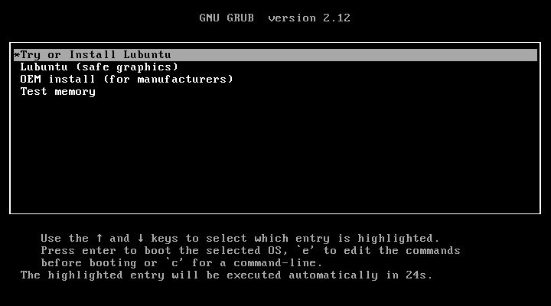

The next screen will present a choice between Try Lubuntu, which will give you a live session to run Lubuntu as you see fit, or run the installer directly with Install Lubuntu. Above this there is a field to select which language you want to install in the Select Your Language drop down. To get this screen in your language, select one then press the Confirm button. If you need more advanced network settings to install Lubuntu than just connecting to Wi-Fi use the Try Lubuntu choice. If choose Install Lubuntu the installer will start right away and install in your language. At the bottom of your screen if you are connected to the internet automatically like with an Ethernet cable it will say Connected at the bottom. If you are not connected to the internet at the bottom it will say Not Connected.

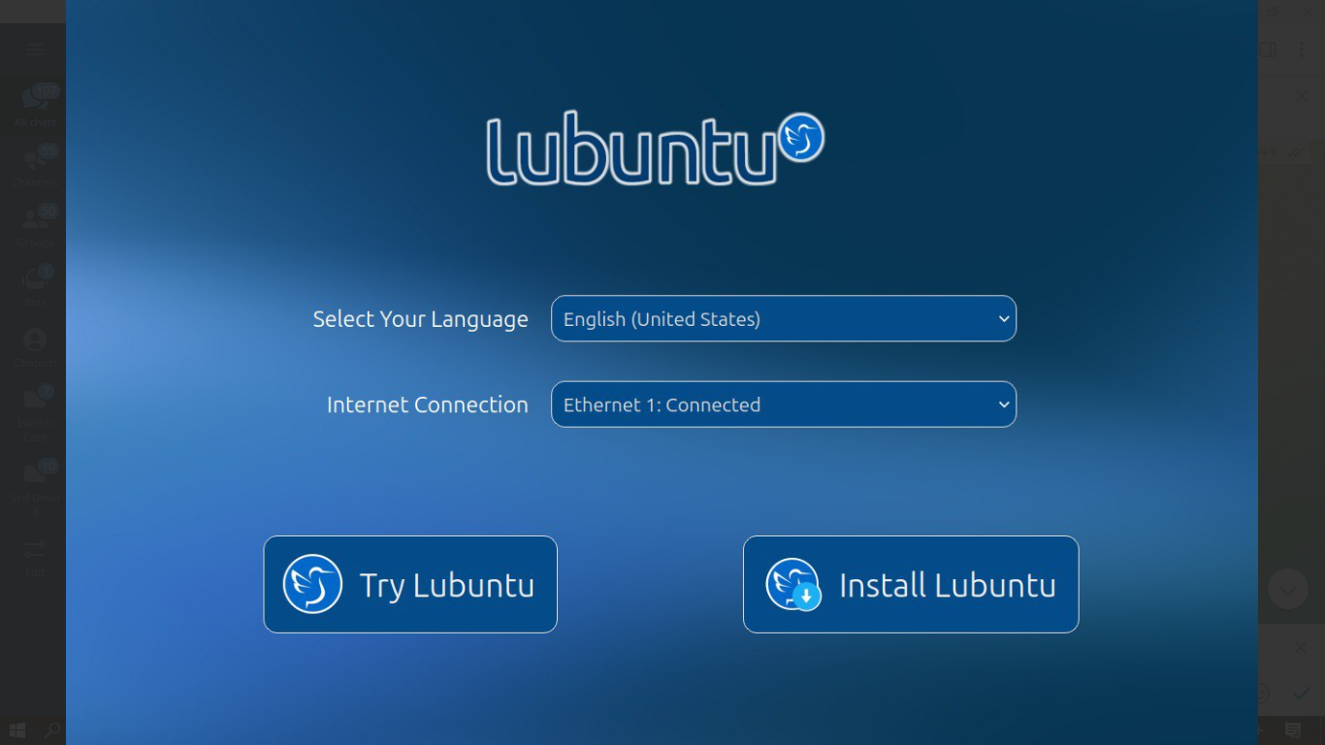

Once you have booted into the live session, feel free to explore Lubuntu and make sure all your hardware works. Once you are ready to install Lubuntu, double click the icon in the top-left corner of the desktop Install Lubuntu 25.04 or System Tools ‣ Install Lubuntu 25.04.

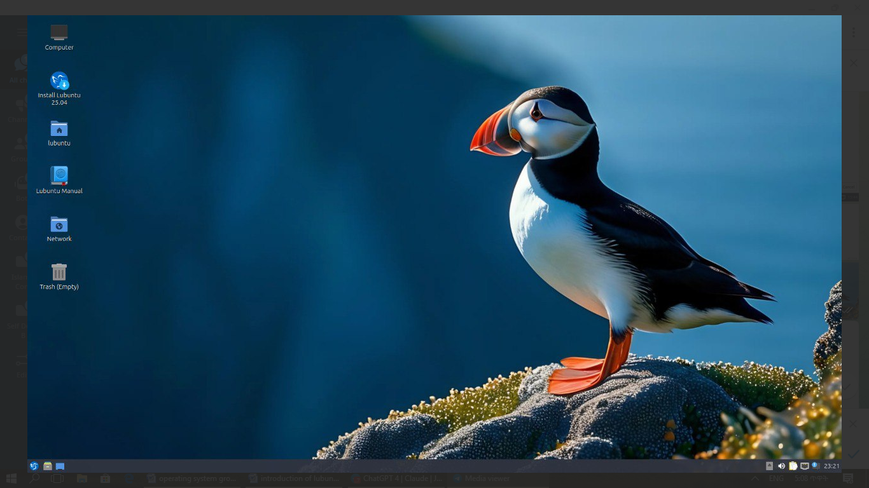

You will be taken to the Lubuntu installer Welcome screen. You can change the installer language in the Language drop down box. After selecting the language the Next button will move you on to the next task. To cancel an installation press the Cancel button. On the left side of the installer is a sidebar that shows what installation step you are on.

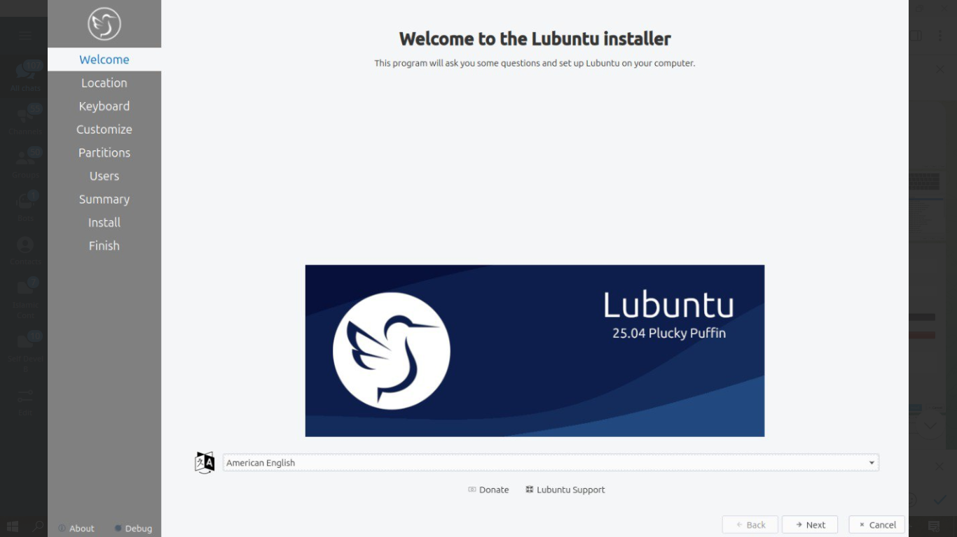

Selecting Your Location

The next screen will show you a map of the world where you can choose your location. Your location will be used to set your time zone and download server. To see what region you have chosen use the Region drop down menu. The Zone field should have a major city with the same time as you. If you want to get to the your time zone manually faster you can type in the name of a big city in the same time zone. Towards the bottom you can to change your system language by pressing the upper Change button. To change the how numbers and dates appear on your system press the lower Change button. To switch certain keys on your keyboard use the Switch Keyboard drop down. To move to the next step once again press the Next button. To move back to selecting your language to change your language press the Back button.

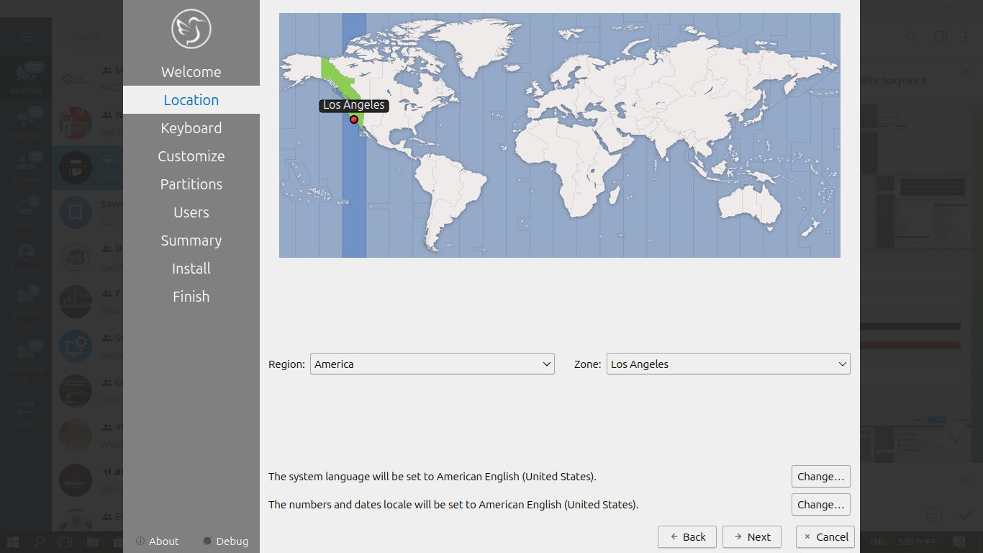

Selecting Keyboard Layout

Next select your keyboard layout, you can check your keyboard matches the keyboard shown picture shown. The Keyboard Model menu lets you choose different variants, the left column lets you change language, and the right column gets different variants. At the bottom you can type to make sure your layout is correct. To test your keyboard is working type in Type here to test your keyboard field. When you have selected your keyboard layout press the Next button to move on. To view a preview of what this keyboard layout looks like look at the top of the window.

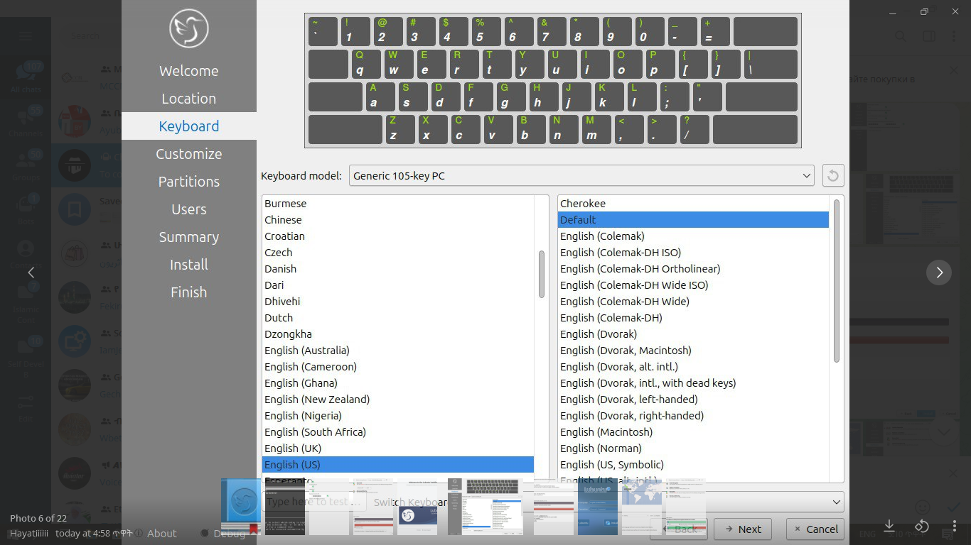

Customize

Next will bring a choice of what applications to install, additional third party drivers, or to install updates with the installation. To choose to install all applications and the list of the third party applications choose Full Installation. To choose the normal applications included in Lubuntu select the Normal Installation button. To choose a minimal installation of just the desktop environment select the Minimal Installation button. To install updates while installing check the Download and install updates following installation checkbox. To install third party and maybe proprietary drivers check the Install third-party software for graphics, WiFi hardware, and additional media formats checkbox.

Pick which particular additional applications you wish to install there are checkboxes for each program under Install additional third party packages. To install Element for encrypted Matrix chat check the Element checkbox. To install the Thunderbird email and calendering client check the Thunderbird checkbox.

To go to the next part of installation press the Next button. To go to selecting your keyboard again press the Back button.

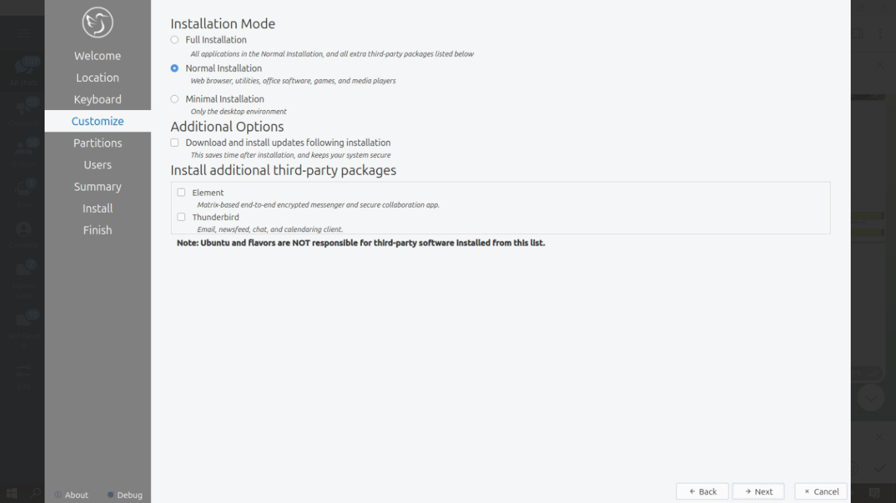

Setting Up Partitions

If all you want is Lubuntu on your machine, you can select the Erase disk button. This will format the disk and delete all data on the disk, which is why having your data backed up before this point is extremely important. If you choose to do this you can continue on to user setup. To change the storage device to install Lubuntu on use the Select Storage device drop down menu. To see whether you are installing in uefi or bios mode is shown in the top left corner of this window. To choose to use a swap file under Erase disk keep Swap to file or to not use swap choose No Swap. To choose which filesystem to use the drop down on the right to choose which filesystem you want to use. If you want to encrypt your drive press the Encrypt system checkbox and then you will need to enter the encryption passphrase twice to make sure you have it typed in correctly. It is strongly advised to write down this passphrase and keep it somewhere safe.

Warning

Erasing your entire disk or partition may cause you to lose data so please backup beforehand.

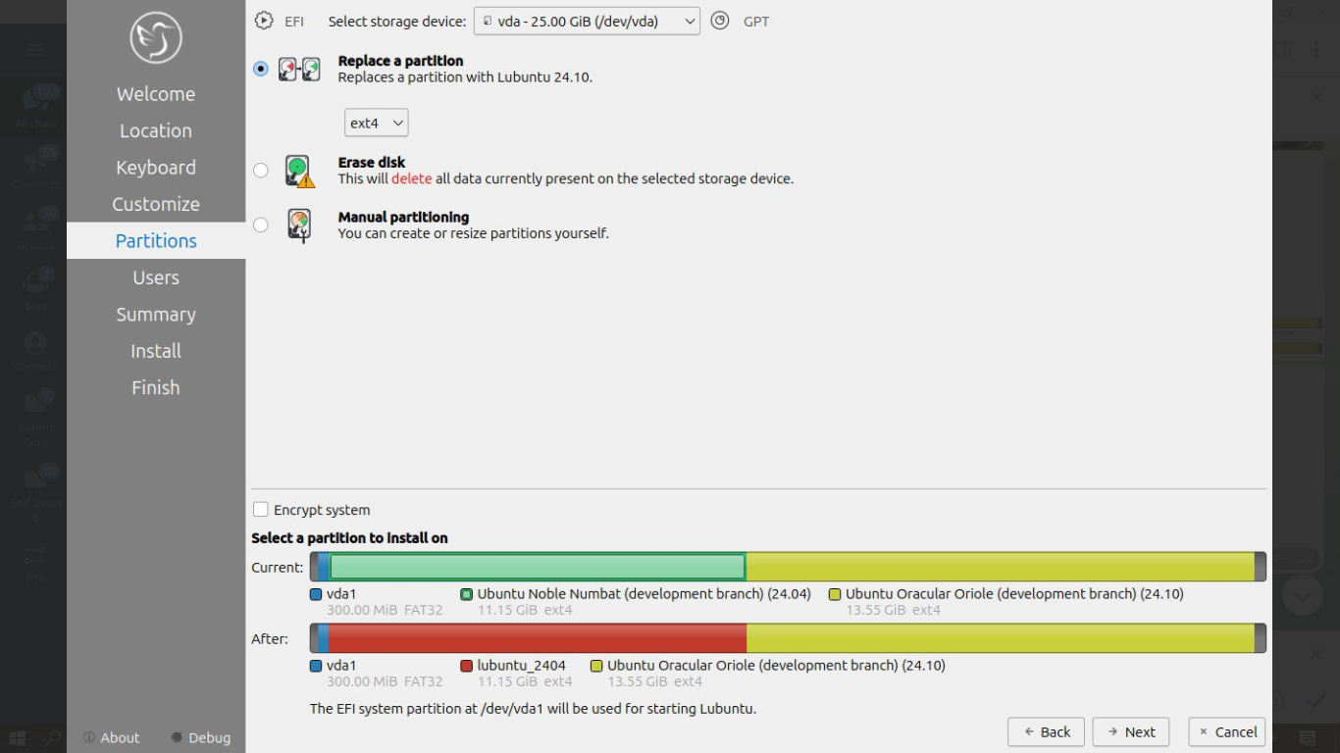

Note

If you had a previous Linux install with a swap partition you will need to unmount the swap. To do this run

sudo swapoff -a; sudo swapon /dev/zram0

which will unmount them and any swap partitions while still leaving zram enabled. This will not work if you have data partition mounted open PCManFM-Qt and press the upward pointed arrow on each partition in the Places sidebar to unmount all data partitions.

To move back to Selecting your keyboard layout press the Back button. To advance to the setting up users press the Next button.

User Setup

The user setup section creates a user profile, consisting of typing your name into the What is your name? field. Next type your username in the What name do you want to use to log in?. Put what you want your hostname of your computer to be in the what is the name of this computer? field. The last thing you need to enter is your password in the Choose a password to keep your account safe. Enter your password twice to make sure you have not mistyped it. To the right of your password will have an x if your passwords don’t match. If you have a weak password to the right will have an orange triangle saying why your password is weak. Passwords less than 8 characters, containing a sequence like 1234, or based off a simple dictionary word like testing1 are considered weak. If a name can actually be used as a username or hostname a green checkmark will appear to the right of it if you cannot a red x will appear. Pressing the Next button will give you a summary screen, showing you the settings before the install begins. Once you have checked the summary click the Install button to begin the installation.

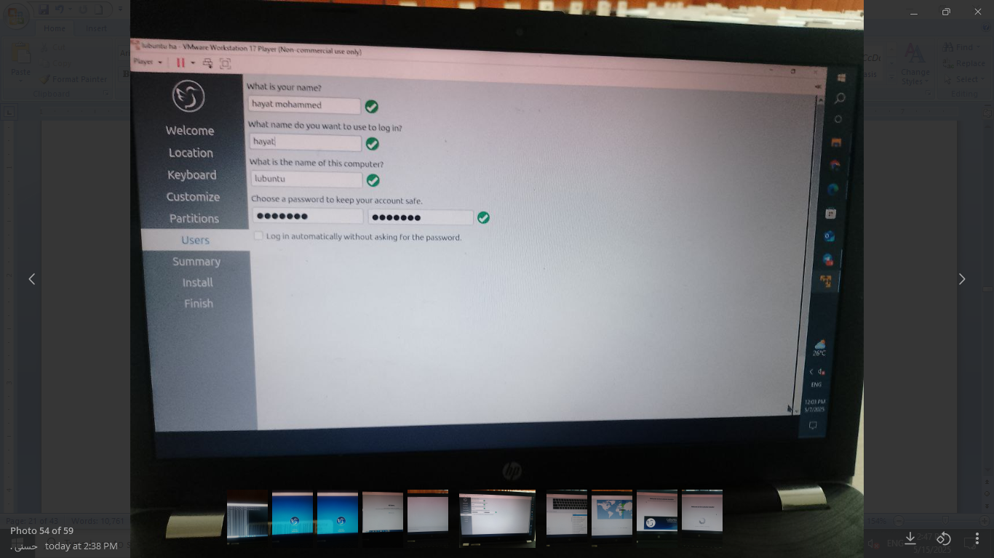

The summary screen shows what settings will be installed and you can double check everything is how you want it. After pressing the Install button a dialog will pop up to confirm installation. To actually install press the Install now button. To not start installing and go back press the Go back button.

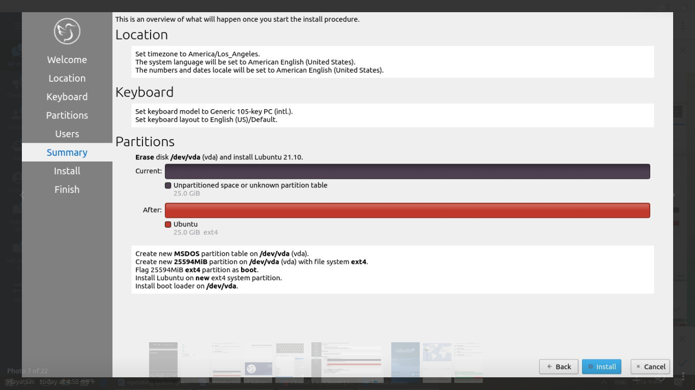

The Install

The Lubuntu installer provides some useful information while the installer is running. On the bottom of the window is a progress bar. On the right end of the progress bar is the percentage of the installation complete. To see command line output of the install press the Magnifying glass button. Once Lubuntu is installed you have a checkbox Reboot now after your Lubuntu is installed and is now finished. There is a slideshow while you install and to move to the next slide left click and to move to the previous slide right click.

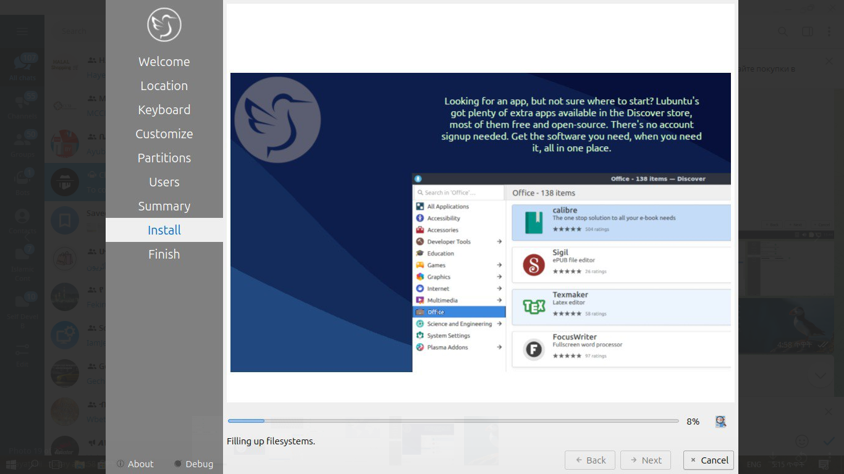

Rebooting into the finished install

After the install is finished you will need to reboot your system into your new install. If you want to continue using the live system but end the installer uncheck the Reboot now checkbox. To close the installer press the Done button. After this your computer will reboot and you should remove your install media.

Install Alongside

To choose to shrink your current partition to install Lubuntu alongside a currently existing install so you can boot into both of them select Install alongside. The Current bar graph shows how much space is currently taken up by a partition. The After section shows how much space will be used by both installs. To change how much space each partition will end up using slide the center back and forth to distribute space between both installs. If you want to encrypt your install check the Encrypt system checkbox.

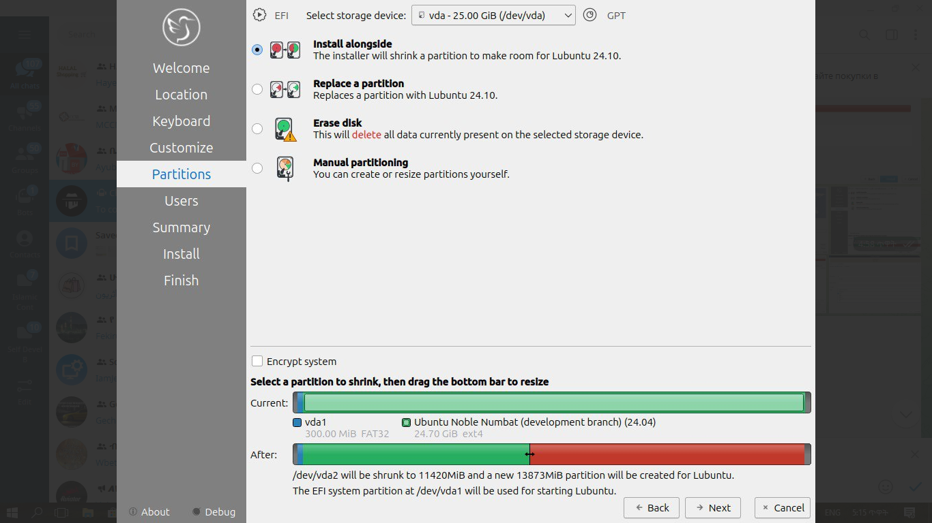

Replace a Partition

To replace a partition select Replace a partition on the Partitions tab. To select which filesystem to install Lubuntu on choose on the drop down under Replace a partition. To select which drive to install on choose in the Select storage device menu. To encrypt your Lubuntu install check the Encrypt system checkbox. To look at your current layout of partitions you have look at the Current bar graph. To see what each partition is listed below the graph. To select which partition to replace left click on the partition on the Current graph. To see the what partitions will be used after the install read the After field. To see the size and filesystem of all partitions view the After bar graph. To see where Lubuntu will boot from is also on the bottom. To continue installing press Next.

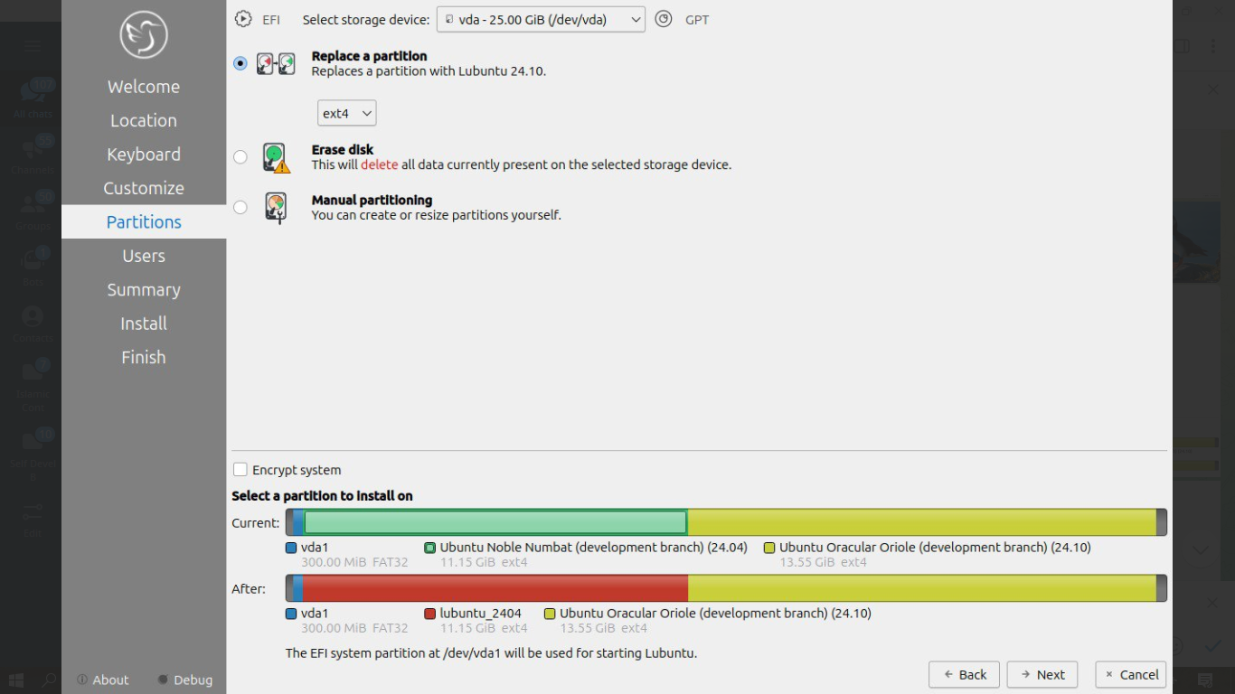

Manual Partitioning

Warning

Trying to use nonlinux filesystems such as NTFS or FAT as your root filesystem will result in a broken system.

If you wish to manual set up partitions, as an advanced option you will have to choose which file-system you want. A file-system controls how your files are accessed at lower levels on the disk. If you are booting your computer in UEFI mode a more modern firmware compared to BIOS you will need to create an EFI system partition (see efi system partition Wikipedia (https://en.wikipedia.org/wiki/EFI_System_partition) for more detail). To create this partition you will need a FAT32 file-system with the ESP flag to be mounted at /boot/efi/ under the mount point. You will also need a root (/) file-system, several file-systems included for Lubuntu are Ext4, XFS, and Btrfs. Lubuntu 22.04 has bug with installing BTRFS and This guide on Lubuntu discourse (https://discourse.lubuntu.me/t/getting-lubuntu-22-04-to-install-with-btrfs/3273/)

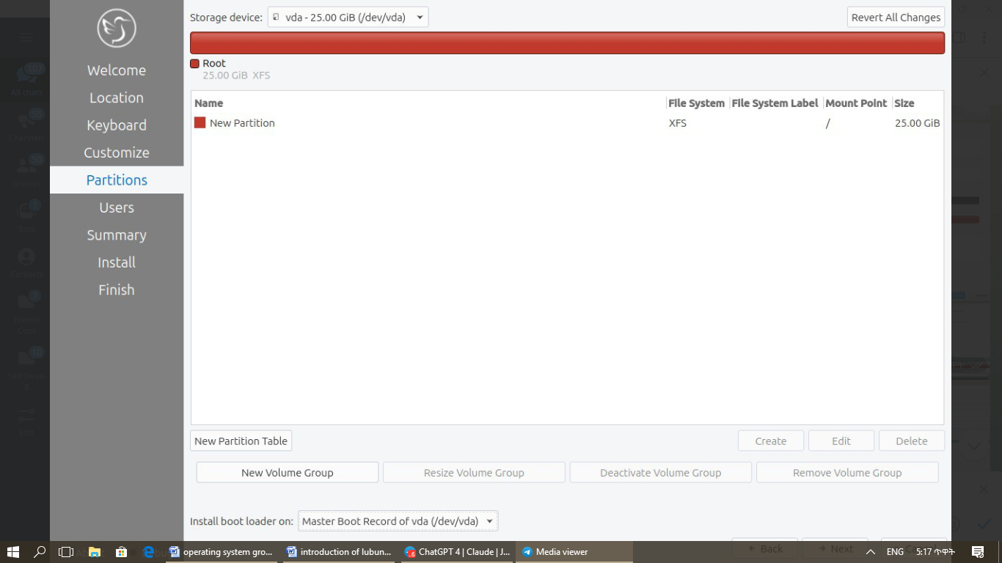

Warning

Creating a new partition table will erase all data on the drive and deleting a partition will delete all data on the partition.

If you have a new hard disk or solid state drive press the New Partition table button but this will delete the whole disc if you have any data on it. After pressing this button you will get a dialog saying what kind of partition table to use. The Master Boot Record button will create an old partition table but will only allow 4 primary partitions and partitions up to 2 Terabytes. The GUID Partition Table button works for large discs but may not be recognized by legacy operating systems. To get back to your main partitioning window press the OK button.

To change what disk you are partitioning use the Storage device drop down menu.

You can create partition by clicking the Create button which will bring up a dialog. The file system field is a drop down menu, select which file-system you want. You also need to select where you want to mount the partition in the Mount Point drop down menu. To change how big to make the partition change the Size field. To change the size or type of a partition after initially creating it press the Edit button. To delete a partition press the Delete button. You will need at least one root (/) partition and if you are booting an EFI system you will also need a /boot/efi mounted partition. Another common option is to have all your data on its own partition, which can even be on its own separate physical disk this can be mounted at /home. If you want to encrypt your your filesystem check the Encrypt checkbox. Then two fields will appear to get write type your encryption passphrase twice to confirm it. To add a label for this partition enter it into the FS Label field.

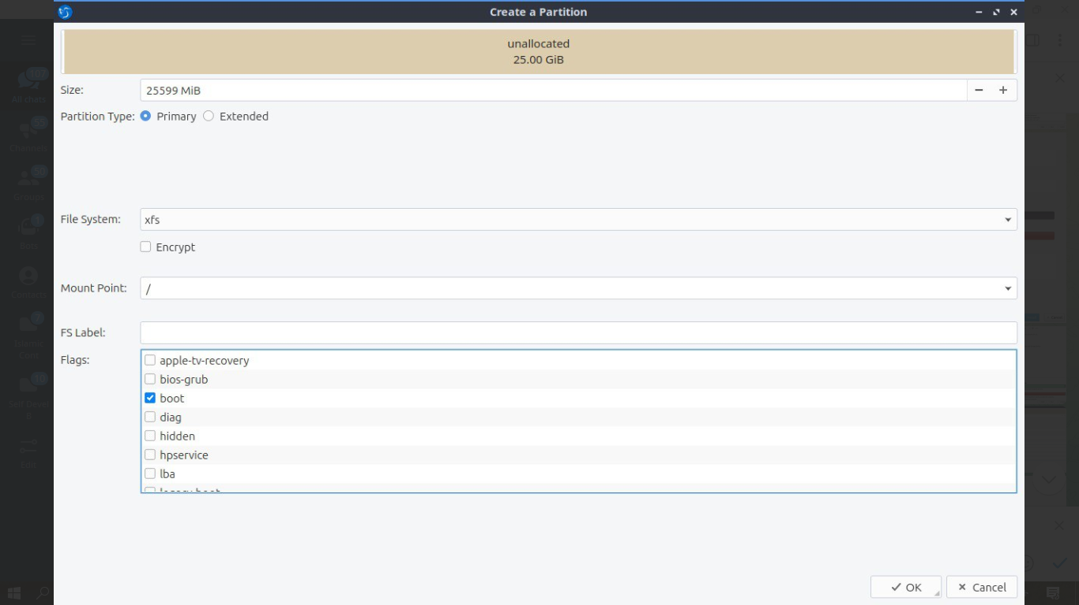

Lubuntu’s bootloader grub does not support creating an encrypted / partition without a separate unencrypted /boot partition. If you create a separate /home partition will be where you save all your user documents photos and videos so make sure if you create one it has enough space for your personal files. All partitions created do not be on the same drive so you can for example put /home on its own drive to give you lots of space and then put / where all of your system and programs will be launched from. A good example of a sensible way to use manual partitioning is if you have a solid state disk and a hard drive in a computer, put the / partition on the solid state drive for faster program launches and /home on the hard drive for more space for your files.

To go back on all your changes to the previous state press the Revert All Changes button in the top right. To change what device your computer will boot off of you will need to use the Install boot loader on drop down menu to select which disc to boot off of.

In the center of the manual partitioning window shows you what name of the partition is. What type of filesystem is displayed in the File System column. To see where your partition is mounted are shown in the Mount Point column. The size of the system is shown in the Size Column.

The top of the manual partitioning window shows a visual bar showing size of your partitions on top. Below it shows each partition on your drive with the color it is in the bar graph and the size of the partition.

OEM Installs

To install Lubuntu in an OEM mode for distributing to someone else on the grub boot splash select OEM install (for manufacturers) or from the panel menu System Tools ‣ Install Lubuntu 24.10 (OEM mode). Then you will be asked if you are sure you want to install in OEM mode and to actually install in OEM mode press the Yes button. Then the installer will say have a welcome screen that will say it is in OEM mode will show up. To change what language to use for installation use the drop down bar under OEM installation mode. To move to the next step of installation press the Next button.

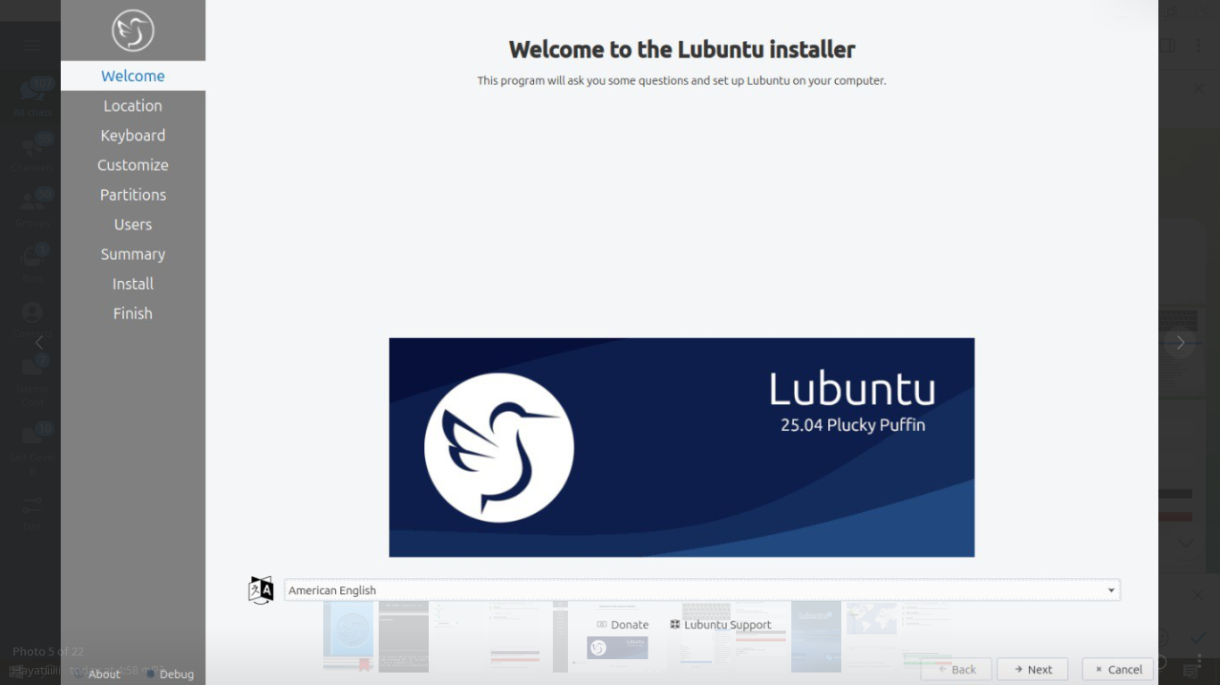

To set a name for what to call this preinstalled system you are installing to ship to someone enter that in the Batch field. To move to the next part press Next To go back to welcome press the Back button. Then the Location, Keyboard, Customize, and Partitions sections are the same as a normal installation. Then for the OEM install you will not be able to make a username as the end user you ship to will use that. To choose a hostname enter in the What is the name of this computer? field. Then you will enter a password twice with Choose a Password to keep your account safe field. To have your OEM install log in automatically check the Log in automatically without asking for the password checkbox. To move to the next part of installation press the Next button.

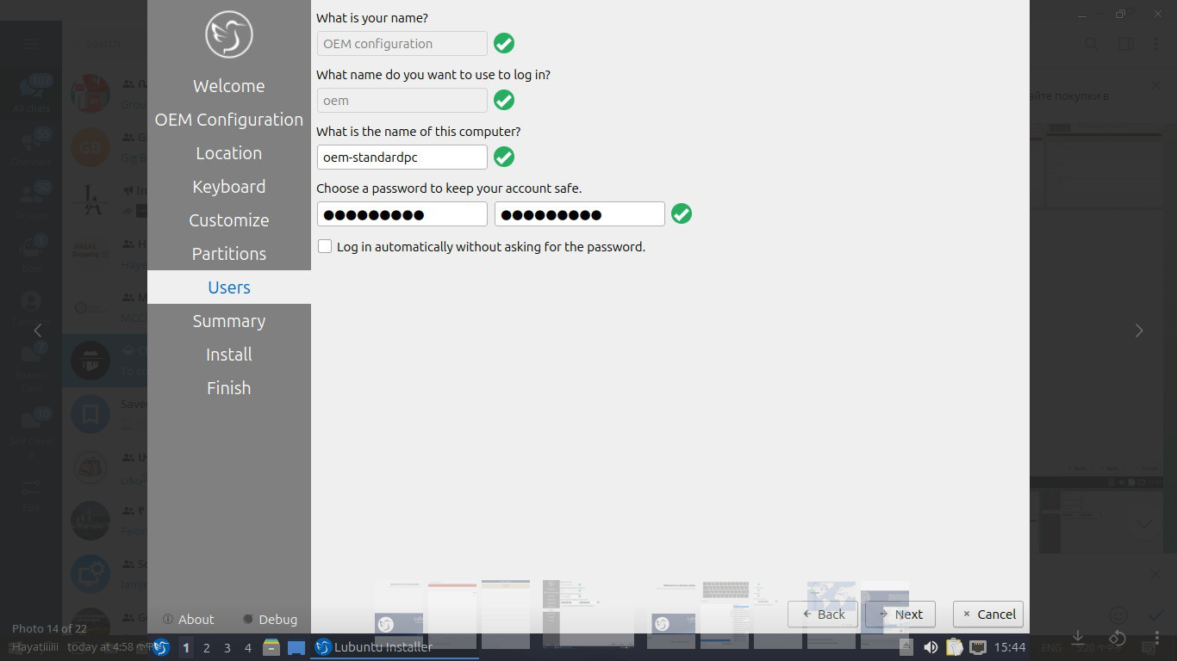

Then a summary screen shows what settings are for your users. To actually begin installing press the Install button and then to confirm that this is what you want press the Install Now button.

Oem User Setup

To setup your user setup for an OEM preinstalled system System Tools ‣ Finish OEM preparation. Then you will be asked if you want to finish OEM setup and then a wizard will be run next boot. Then press Yes to confirm this. Then you will need to reboot to run the user setup.

The first section of user setup will ask you what language to continue in at the very bottom. To go to the next part of Lubuntu setup press the Next button.

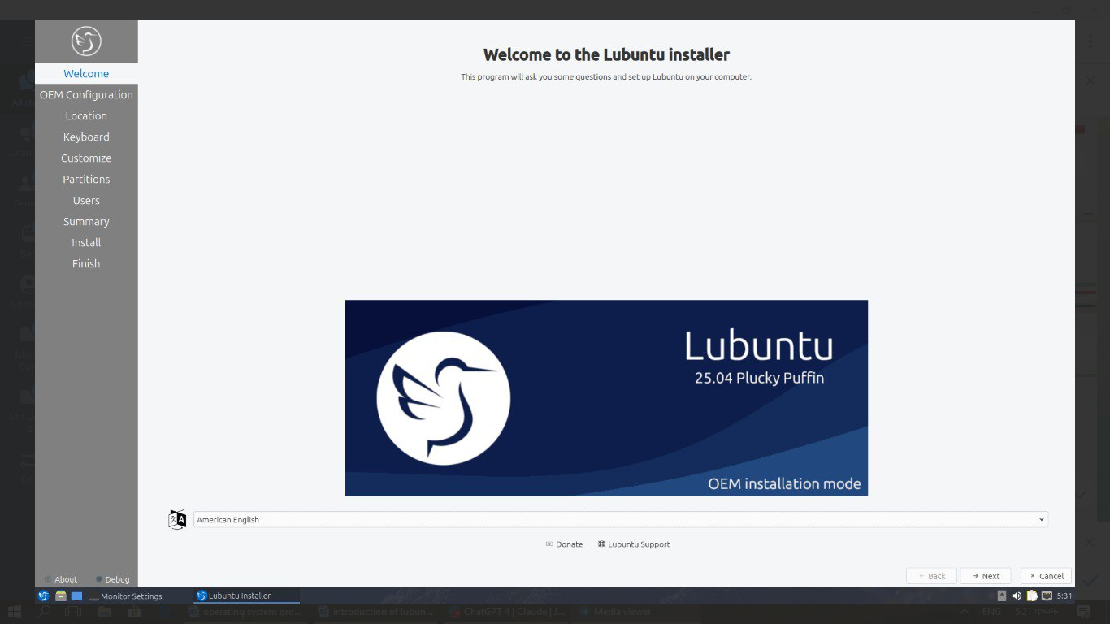

Next you will need to select your time zone in the Region and Zone fields with a world map above them to tell you what time it is set to. To set what language the system will boot into press the Change button next to The system language will be set to field. To change how date and number formatting press the Change button next to The numbers and dates locale will be set to field. To go to the next part of Lubuntu setup press the Next button.

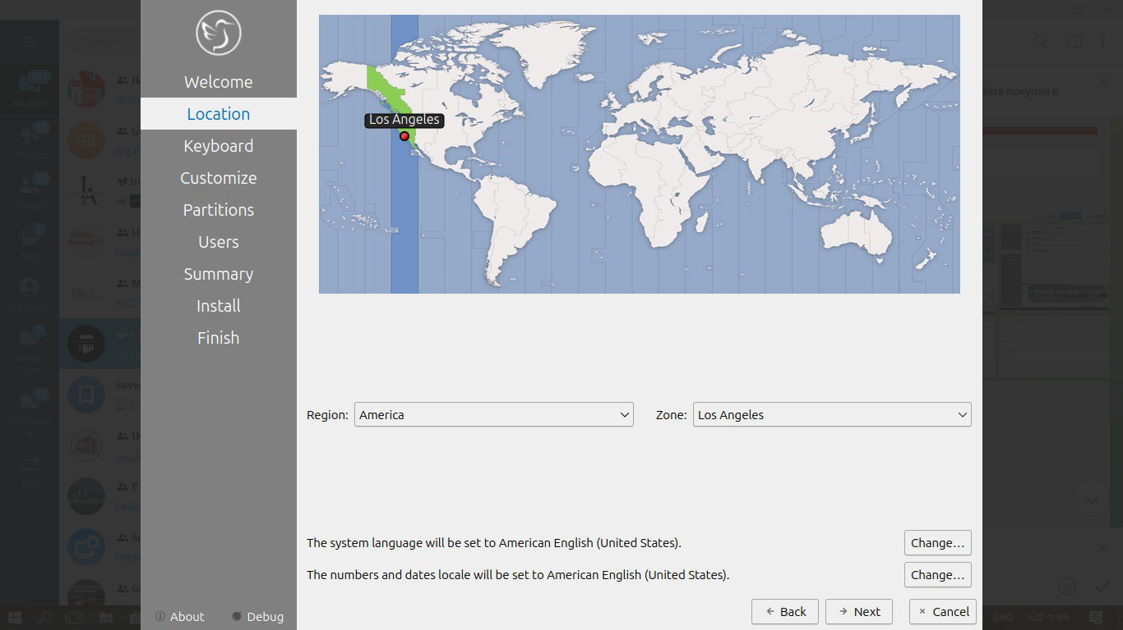The next part of setup will have be selecting your keyboard layout. To change the what kind of keyboard model you are using change the Keyboard model field. The left column sets the language of your keyboard while the right column selects a layout for that keyboard. In the bottom left hand corner you type to make sure what you think you are typing matches what is being input. To set a key to change keyboard layout select one from the Switch keyboard field. To move on to setup your users press the Next button.

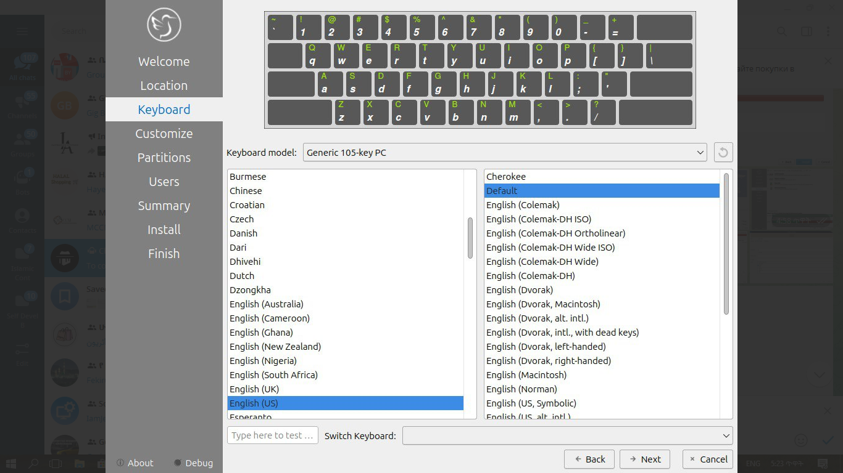

Next is to set up your users for your computer. To then enter your name in the What is your name field. To enter your username in the login field. Enter your hostname in What is the name of your computer. Then type your password twice to make sure you didn’t mistype in in the fields under Choose a password to keep your account safe field. To login automatically check the Log in automatically without asking for the password checkbox.

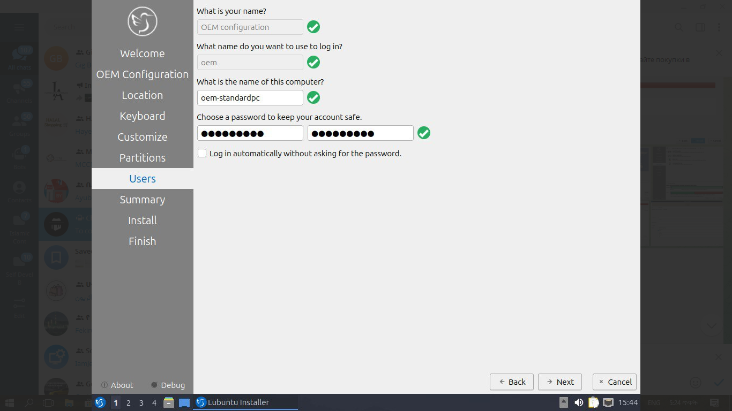

Next step to finalize creating users and keyboard and language settings press the Set Up button. At this point you will be asked to confirm because you cannot undo after this step. To continue with all your settings press the Set Up Now. Then the users will set up with a slideshow and you will then reboot and then can login to reboot and use Lubuntu is ready to use.

**The problem that I face in the installation of lubuntu operating system**

During the installation of the Lubuntu operating system, i may encounter several common issues. One of the main problems is hardware compatibility. Some older or very new hardware components, such as Wi-Fi adapters, graphics cards, or touchpads, may not be recognized automatically during installation. This can result in limited functionality or the need to find and install additional drivers after the system is installed. Another issue could be related to the creation of the bootable USB, where improper formatting or corrupted ISO files prevent the system from booting properly. Users must ensure they use reliable tools like Rufus or Balena Etcher and verify the ISO integrity before starting the installation.

Additionally, partitioning problems can arise, especially if the user is trying to dual-boot Lubuntu with another operating system like Windows. Incorrect partitioning might lead to data loss or bootloader issues, making other operating systems inaccessible. It's also possible to encounter secure boot or UEFI-related issues on modern systems, which require users to disable secure boot or switch to legacy mode in BIOS settings. Finally, a power interruption or insufficient disk space during the installation can cause the process to fail. Preparing the system by backing up data, fully charging the battery (if using a laptop), and checking hardware compatibility can help prevent these problems

**The solution that I create for the problem that I face in the installation lubuntu operating system**.

During the installation of the Lubuntu operating system, I faced several problems. First, there was a hardware compatibility issue. Some hardware like the Wi-Fi adapter and graphics card were not recognized. To solve this, I searched for the missing drivers after installation and installed them manually. Then, I had a problem with creating a bootable USB. The system didn’t boot because the ISO file was corrupted. I solved it by downloading the ISO file again from the official Lubuntu website and using a trusted tool called Rufus to create a new bootable USB.

Another issue I encountered was during disk partitioning, especially when trying to install Lubuntu alongside Windows. I was afraid I might delete my data. To fix this, I first backed up all my important even to back up I face a lot of struggles nfiles, then carefully created a new partition using the manual partition option during installation. I also faced a problem with secure boot, where the system refused to boot from the USB. I solved it by going into the BIOS settings and disabling Secure Boot, then switching the boot mode to Legacy. Finally, I made sure my laptop batt Certainly

**Filesystem support lubunt operating system**,

During the installation of the Lubuntu operating system, I encountered a decision point regarding the file system to use. The installer presented several options, including ext4, Btrfs, and others. I chose the ext4 file system because it is the default and most recommended option in the Lubuntu installation manual. Ext4 is known for its stability, performance, and wide compatibility with Linux systems. It efficiently handles large files and partitions, making it suitable for both personal and professional use.

I also learned that using non-Linux file systems like NTFS or FAT for the root partition can lead to a broken system, as highlighted in the manual. Therefore, selecting ext4 ensured a smooth and reliable installation process. The manual also mentioned that while Btrfs is available, it has known issues in certain Lubuntu versions, making ext4 the safer choice. By following the manual's guidance and choosing ext4, I ensured that my Lubuntu system would function correctly and efficiently.

**Advantage of lubuntu operating system**

Lubuntu is very lightweight.

One of the biggest advantages of Lubuntu is that it's extremely light on system resources. This means it works smoothly even on older or low-spec computers. For students like me who don’t have high-end laptops, Lubuntu helps us get things done without lag or crashes.

It boots fast and runs efficiently.

Since Lubuntu uses the LXQt desktop environment, it starts up quickly and doesn't use too much RAM or CPU in the background. This makes it perfect for people who want speed and efficiency without all the fancy visual effects that slow down other operating systems.

It's open-source and completely free.

Like other Linux distributions, Lubuntu doesn’t cost anything to download or use. This is a huge advantage, especially for students and people who want a reliable operating system without paying for licenses like Windows or macOS.

It’s great for learning Linux.

Using Lubuntu helped me learn how Linux works, especially when working on system-level tasks like this project. Since it’s close to Ubuntu and uses the same package manager, I could install tools, compile programs, and explore the terminal easily.

Lubuntu has strong community support.

Although it’s not as popular as Ubuntu, Lubuntu still has a supportive community. I found a lot of tutorials, forum posts, and videos online that helped me solve problems. The documentation is also very helpful for beginners.

**Disadvantage of lubuntu operating sytem**

the user interface feels a bit outdated.

One disadvantage I noticed is that Lubuntu’s interface isn’t as modern or attractive as other desktops like GNOME or KDE. While it runs faster, it sometimes looks old-fashioned, which might not appeal to users who prefer a polished design.

It lacks some default software.

Another downside is that Lubuntu comes with fewer built-in applications compared to Ubuntu. This is done to keep it lightweight, but it means I had to install some basic tools manually, like LibreOffice or media players.

Not ideal for gaming or heavy graphics work.

Lubuntu isn’t the best choice for people who want to play games or use software like Adobe Photoshop or video editors. Since it’s designed for performance and not graphics, it doesn’t support some advanced features or drivers out of the box.

Limited support for some modern hardware.

Because it targets older hardware, Lubuntu may not fully support newer devices like fingerprint sensors or high-resolution displays. I didn’t personally face this issue, but I read about it in online forums.

It’s best suited for lightweight, everyday tasks.but not for the reverse

Overall, I think Lubuntu is a great operating system for browsing the web, coding, writing, and doing schoolwork. But for tasks that require a lot of power or visual design, other Linux distributions might be a better choice.

**conclusion**

**Lubuntu is a lightweight, fast, and energy-efficient Linux-based operating system built on the Ubuntu core but designed to run smoothly on older or low-spec hardware. It uses the LXQt desktop environment, which is clean, simple, and requires fewer system resources. Lubuntu is ideal for students, developers, or anyone looking for a free and reliable system that boots quickly and handles daily tasks like browsing, writing, coding, and more. It comes with essential applications pre-installed and supports thousands more through the Ubuntu Software Center.**

**Installing Lubuntu is a straightforward process once you have the ISO file and a bootable USB ready. The system uses the ext4 file system by default, ensuring stability, speed, and long-term support. You can choose to erase your disk or install it alongside another operating system, like Windows. The installer walks you through each step—from selecting your language to creating a user account. Once installed, Lubuntu offers a clean interface and smooth experience, even on computers with limited RAM or old processors.**

**the what of modern visualization operating system**

Virtualization is a foundational technology in modern computing that allows a single physical hardware system to be divided into multiple, independent, and isolated environments called virtual machines (VMs). Each virtual machine operates like a separate computer system, complete with its own operating system (OS), storage, and applications. This is made possible through the use of specialized software known as a hypervisor or virtual machine monitor (VMM), which manages the distribution of hardware resources to each VM and ensures that they function smoothly without interfering with one another.

In traditional computing, one operating system runs directly on one physical machine, meaning all applications and processes share the same OS environment. However, this setup can be inefficient, especially when different applications require different OS environments, or when one application crashes and brings down the entire system. Virtualization solves this problem by allowing multiple OS environments to coexist on a single physical system. This increases flexibility, system utilization, and isolation, enabling organizations to run a variety of services more reliably and cost-effectively.

At the core of virtualization is the concept of abstraction. The hypervisor abstracts the physical hardware and presents each virtual machine with a virtualized hardware environment. For example, a VM may be configured to believe it has access to 4 GB of RAM and a 100 GB hard drive, when in reality, those resources are shared with other VMs and managed by the hypervisor. This abstraction allows for better resource allocation, making it easier to scale computing environments based on need without having to physically change the hardware.

There are two primary types of hypervisors used in virtualization: Type 1 and Type 2. Type 1 hypervisors, also known as bare-metal hypervisors, run directly on the physical hardware and manage the virtual machines from the ground up. Examples include VMware ESXi and Microsoft Hyper-V. Type 2 hypervisors, on the other hand, run on top of an existing operating system like an application. Examples include VirtualBox and VMware Workstation. While Type 1 hypervisors are typically used in enterprise environments for better performance and control, Type 2 hypervisors are more common for personal use and small-scale development.

Virtualization enhances security and isolation in computing environments. Since each virtual machine operates independently, a problem in one VM does not affect the others. This isolation is particularly useful for testing new software, running legacy applications, or experimenting with different operating systems without risking the host system. Moreover, if a virtual machine gets infected with malware, it can be easily deleted and restored from a clean snapshot without compromising the rest of the system.

Another major advantage of virtualization is resource optimization. In many traditional setups, physical servers often operate below capacity, wasting valuable computing resources. With virtualization, multiple virtual machines can be hosted on a single server, maximizing hardware utilization. This not only reduces the number of physical machines needed but also lowers costs related to energy, maintenance, and space. As a result, organizations are able to reduce their carbon footprint and save money while maintaining high levels of performance.

"**how" part of virtualization in operatin gsystem**

Virtualization works through a layer of software called the hypervisor, which acts as an intermediary between the physical hardware and the virtual machines (VMs). When the operating system and applications inside a VM request access to hardware components like the CPU, memory, disk, or network interface, the hypervisor intercepts these requests and translates them into commands that the real hardware can understand. This process creates an illusion for each virtual machine that it has its own dedicated hardware, even though it’s sharing the same physical system with other VMs. The hypervisor ensures that all VMs get fair and efficient access to the resources without interfering with one another.

The hypervisor also allocates resources such as RAM, CPU cores, and disk space to each virtual machine. These allocations are flexible and can be adjusted depending on the performance needs of each VM. For instance, a lightweight application may only require 1 GB of RAM, while a database server VM may need 8 GB or more. The hypervisor monitors the system's usage in real time and can dynamically adjust these allocations if needed, a process known as resource scheduling. Advanced hypervisors can even move VMs between physical hosts (a process called live migration) without shutting them down, which is very useful for maintenance and load balancing.

To enable virtualization, the host operating system or hardware must support certain features. Most modern CPUs from Intel and AMD come with built-in virtualization support—Intel VT-x or AMD-V—that makes virtualization faster and more secure. Operating systems like Linux, Windows, and macOS can use these CPU features to improve the performance of virtual machines. Additionally, specialized drivers and kernel modules are used to handle virtual I/O (input/output) operations, which further enhances the VM's ability to access disk storage, networks, and USB devices just like a real physical system would.

Virtual machines are usually created and managed using virtualization platforms or tools. These tools provide user interfaces that allow users to configure VM settings, install operating systems, and manage snapshots (saved states of the VM). For example, a user can create a Lubuntu virtual machine inside Oracle VirtualBox, assign it 2 GB of RAM and 20 GB of virtual disk space, and run it on a Windows host machine. Behind the scenes, the virtualization tool builds a virtual hardware environment, mounts an ISO image to install the operating system, and allows the VM to operate just like a separate computer.

In large-scale environments, such as data centers or cloud infrastructure, virtualization is managed by orchestration platforms like VMware vSphere, Microsoft System Center, or open-source tools like Proxmox and OpenStack. These platforms automate the deployment, scaling, and management of hundreds or thousands of virtual machines. They work alongside hypervisors to ensure high availability, disaster recovery, and security enforcement. System administrators can remotely monitor VMs, adjust

configurations, or move workloads across servers with minimal downtime. This is how modern operating systems and infrastructures use virtualization to achieve reliability, flexibility, and powerful computing at scale.

**The why of modern visualization operating system**

One of the main reasons virtualization is used in modern operating systems is to maximize hardware utilization. In traditional systems, a single operating system runs on one physical machine, often leaving large amounts of CPU, memory, and storage underutilized. With virtualization, multiple virtual machines can run on the same hardware, each using a portion of the available resources. This helps organizations make the most out of their hardware investments by ensuring that no physical resource goes to waste, resulting in better performance and reduced operational costs.

Virtualization is also important for cost savings and efficiency. By consolidating several virtual machines on a single server, companies can reduce the number of physical machines they need. This lowers the cost of purchasing new hardware and also reduces expenses related to electricity, cooling, and space. Moreover, it simplifies system management and maintenance because IT teams have fewer physical systems to monitor, repair, or upgrade. Over time, these savings contribute to significant financial and operational advantages, especially in large data centers and enterprise environments.

Another reason virtualization is widely used is its ability to improve system reliability and security. Each virtual machine is isolated from the others, meaning that if one VM crashes or is attacked by malware, it does not affect the other VMs or the host system. This isolation provides a safer environment for testing new software, experimenting with unknown applications, or running potentially risky tasks. In critical systems, this feature helps protect data and ensures that services continue running smoothly even when problems occur in one part of the system.

Virtualization supports flexibility and scalability, which are essential in today’s fast-changing technology landscape. It allows users to quickly create, duplicate, or delete virtual machines depending on their needs. For example, a software developer can easily set up multiple VMs with different operating systems to test applications across platforms. Similarly, companies can rapidly scale up their systems during peak usage times by adding more virtual machines, then scale down when the demand drops. This agility helps businesses respond faster to challenges and reduces downtime.

Lastly, virtualization is critical for supporting modern computing trends like cloud services, DevOps, and remote work. Most cloud providers rely on virtualization to deliver Infrastructure as a Service (IaaS), allowing customers to run virtual machines in the cloud. Developers use virtual environments to build and test applications without affecting the host machine. Virtual desktops allow employees to access their work environments from anywhere, making remote work more efficient and secure. In short, virtualization is the backbone of many modern IT services, making it an essential technology for today’s digital world.

**Implementation of rename() System Call in Lubuntu**

Lubuntu is a lightweight, fast, and energy-efficient Linux-based operating system built on the Ubuntu core but designed to run smoothly on older or low-spec hardware. It uses the LXQt desktop environment, which is clean, simple, and requires fewer system resources. Lubuntu is ideal for students, developers, or anyone looking for a free and reliable system that boots quickly and handles daily tasks like browsing, writing, coding, and more. It comes with essential applications pre-installed and supports thousands more through the Ubuntu Software Center.

Installing Lubuntu is a straightforward process once you have the ISO file and a bootable USB ready. The system uses the ext4 file system by default, ensuring stability, speed, and long-term support. You can choose to erase your disk or install it alongside another operating system, like Windows. The installer walks you through each step—from selecting your language to creating a user account. Once installed, Lubuntu offers a clean interface and smooth experience, even on computers with limited RAM or old processors.

In this project, I implemented the rename() system call on a custom Linux kernel used by Lubuntu. The goal was to understand how system calls work by creating my own version of rename() and integrating it into the Linux kernel source. This document explains the process step by step, including setup, code implementation, compilation, and testing

Well-Organized Implementation of my_rename() System Call in Lubuntu

**1. Create the Source File**

Navigate to the fs/ directory inside the kernel source and create a new file:

cd ~/kernel/linux-5.10/fs touch my_rename.c

2. **Code: my_rename.c**

#include <linux/kernel.h>

#include <linux/syscalls.h>

#include <linux/fs.h>

#include <linux/namei.h>

#include <linux/uaccess.h>

SYSCALL_DEFINE2(my_rename, const char __user

*oldname, const char __user *newname) {

char old[PATH_MAX], new[PATH_MAX];

struct path old_path, new_path;

int err;

// Copy file paths from user space

if (copy_from_user(old, oldname, PATH_MAX)

|| copy_from_user(new, newname, PATH_MAX))

return -EFAULT;

// Get the parent directory of the old path

err = kern_path(old, LOOKUP_PARENT, &old_path);

if (err)

return err;

// Get the parent directory of the new path

err = kern_path(new, LOOKUP_PARENT, &new_path);

if (err) {

path_put(&old_path);

return err;

}

// Perform rename operation

err = vfs_rename(d_inode(old_path.dentry),

old_path.dentry,

d_inode(new_path.dentry), new_path.dentry,

NULL, 0);

// Release resources

path_put(&old_path);

path_put(&new_path);

return err;

}

**3. Register the System Call**

a. Add to Makefile

Edit fs/Makefile and add:

obj-y += my_rename.o

b. Add Prototype

In include/linux/syscalls.h, add:

asmlinkage long sys_my_rename(const char __user

*oldname, const char __user *newname);

**c. Add to Syscall Table**

Edit arch/x86/entry/syscalls/syscall_64.tbl:

440 common my_rename __x64_sys_my_rename

4. **Recompile and Reboot**

make -j$(nproc)

sudo make modules_install

sudo make install

sudo update-grub

sudo reboot

**5. Test the System Call**

Create test program test.c:

#include <stdio.h>

#include <unistd.h>

#include <sys/syscall.h>

#define __NR_my_rename 440

int main() {

long result = syscall(__NR_my_rename, "old.txt", "new.txt");

if (result == 0)

printf("Rename successful\n");

else

perror("Rename failed");

return 0;

}

**Compile and Run:**

gcc test.c -o test ./test

Conclusion

Through this project, I learned how system calls are handled by the Linux kernel. By implementing a simplified version of rename(), I understood file system handling, kernel space vs user space communication, and the process of customizing the kernel. This project helped me gain practical experience in kernel development Virtualization also plays a key role in cloud computing, which relies on the dynamic provisioning of computing resources. Cloud service providers use virtualization to offer customers scalable and flexible virtual environments. Customers can deploy virtual machines in the cloud for web hosting, data storage, software development, and more. Without virtualization, cloud computing as we know it would not be possible, as the ability to quickly create, manage, and move virtual environments is essential for cloud infrastructure.